Everything you need to know about:
Spinal Stenosis

What is spinal stenosis?
The term spinal stenosis refers to a loss of the free space in your spine where your nerves usually travel. The word stenosis comes from the Greek word stenos which means “narrow.” The space that is narrowed in spinal stenosis is called the “spinal canal.” The spinal canal is essentially a long tunnel that runs all the way from the brain down to the end of your backbone. The spinal cord and nearly all the other nerves that transmit information between your brain and your body live in the spinal canal. This means that when you have spinal stenosis, your spinal cord or nerve roots can end up getting pinched. Pinching of the nerves in your spine leads to the typical symptoms of spinal stenosis: pain, numbness, and weakness. Pain may be partially caused by pinched nerves and partially caused by the arthritis and disc problems that often go hand in hand with spinal stenosis. Pain caused by spinal stenosis might start in the low back or neck, but nearly always radiates down the arms or legs. This sets it apart from arthritis or disc-related pain, which lingers in the back and usually doesn’t radiate. Numbness and weakness are also symptoms that are more unique to spinal stenosis.
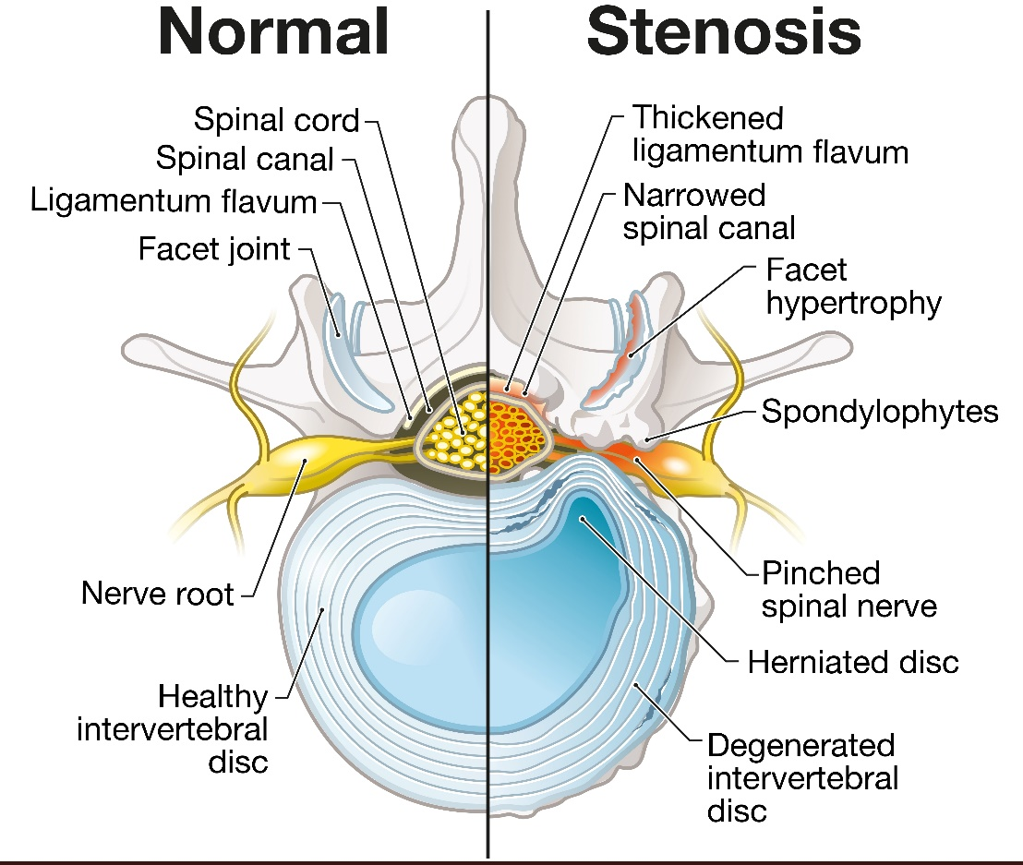

What do the terms in my MRI report mean?
MRI reports are notoriously long and detailed, making them difficult for a patient to understand. This is because the radiologist who writes these reports is required to describe everything they see in detail, even things that are normal, to ensure that nothing gets missed. The most important part of the report is the section titled “impression” or “summary,” because this is where the radiologist highlights the major findings.
In an MRI report for spinal stenosis, the radiologist will identify each part of the spinal canal where there is stenosis, as well as the severity or degree of stenosis. This is usually done by first identifying the levels of the spine where the stenosis is. Each bone or vertebra in your spine is identified by a letter and a number. The letter refers to the general area of the spine, and the number is the exact vertebra within that area. For example, the L4 vertebra is the fourth lumbar (low back) vertebra, counting from the top. In reports you will see levels referred to by two vertebrae with a dash between them (i.e., C3-C4 meaning between the third and fourth neck vertebrae), this indicates the part of the spinal canal in between those two vertebrae.
Most reports will get even more detailed, talking about which areas of each level are narrowed and how severe the narrowing is. This explains why you might see location terms like central, posterolateral, or foraminal stenosis, and severity terms like mild, moderate, or severe stenosis. Generally, radiologists do not follow hard and fast rules when applying these terms, and therefore seeing the words ‘severe stenosis’ shouldn’t trigger a panic! The key thing to keep in mind is that the severity of your symptoms and how you respond to treatment is much more important than the descriptive words that are used in your MRI report.

How did I end up with spinal stenosis?
Spinal stenosis is a natural and nearly inevitable part of the aging process. Like grey hair or wrinkles, once you reach a certain age it is very likely that you have developed some degree of spinal stenosis.¹ However, only a percentage of those who have spinal stenosis actually end up getting symptoms from it or needing treatment.² We do not have a reliable way to predict who will be able to live with stenosis and who will ultimately need treatment of some sort. The severity and location of the narrowing plays an important role, as does genetics (whether spinal problems run in your family) and the presence of other conditions such as diabetes.
Spinal stenosis is so common because it is a natural consequence of disc degeneration and the development of arthritis in the spine. Those are both complex topics deserving their own explanations. Suffice it to say that as we get older the structural parts of our spines start to wear down, and as they do they grow in size and start to occupy the space normally reserved for the spinal cord and nerves.
Note that the above paragraphs explain what is called ‘degenerative spinal stenosis,’ or the stenosis that occurs as part of the natural wear-and-tear of the spine. Spinal stenosis is sometimes caused by other things, like scoliosis, spinal instability, disc herniation, a spinal fracture, or a tumor in the spine. The vast majority of those who have spinal stenosis have simple degenerative spinal stenosis, but it is important to understand whether there is another contributing factor in your case.

What treatment options are available?
As mentioned above, many of those who have spinal stenosis will not end up requiring any sort of treatment for it. However, some will develop symptoms severe enough to seek relief, and there are several effective treatment options, both invasive and non-invasive. I have organized the treatment options below from least invasive/lowest-risk, to most invasive/highest-risk. Treatment should be mutually decided on by you and your physician, but generally, invasive options are only considered when less invasive alternatives have failed.
Physical Therapy
Physical therapy has a good track record of success in reducing symptoms from spinal stenosis.³ Therapy will usually be focused on building strength and flexibility in your core and back muscles. While therapy does not directly reverse the narrowing that is happening in the spinal canal, strengthening the support around your spine can greatly reduce or eliminate symptoms. This is because the day-to-day symptoms of stenosis usually occur when the spine is subjected to extreme strain or abnormal positioning, which can be reduced through therapy.
Medications
Medications that work well in spinal stenosis include non-steroidal anti-inflammatory drugs (NSAIDs, such as Advil ®, Motrin ®, or Aleve ®), steroids, and pain medications. Both NSAIDs and steroids work by calming down the process of inflammation that occurs in spinal stenosis. NSAIDs can lead to side-effects such as stomach upset, ulcer formation, and increased risk of bleeding, and so a doctor should be consulted before starting one. Steroid medications are more potent at reducing inflammation than NSAIDs, but due to multiple side-effects, steroids should be avoided as a chronic medication and are often used for acute symptom flare-ups. Pain medications alter and dull your perception of pain, but do not impact the underlying problem and can be addictive if taken for long periods.
Non-surgical Procedures
The most common and effective non-surgical procedure to help relieve symptoms of spinal stenosis is an epidural steroid injection (ESI). To describe it briefly, during an ESI, steroid medication is delivered to the precise location along the spine where stenosis is the worst. This is typically done under X-ray guidance with light sedation. As was mentioned above, steroid medications have a very strong anti-inflammatory effect, but cannot be taken for a long time due to side-effects. ESIs get around this restriction by delivering a very small amount of steroid directly to the area of the problem. Very little of the medication goes to any other part of the body, nearly eliminating the drug-related side effects. ESIs can be effective for several months or years, and can help some patients avoid surgery.⁴
Chiropractic adjustments, acupuncture, and non-invasive decompression procedures are other options for patients looking to avoid surgical treatment. While each of these treatments have worked well for some patients, so far there has not been any high-quality research showing that these treatments are more effective than a placebo (decoy/sugar pill). Therefore, caution should be used when deciding to take on any of these treatments, particularly if it is expensive.
Surgery
If all other treatments have been tried and are not providing enough relief, surgery is a definitive treatment that is very effective at greatly reducing or eliminating spinal stenosis and the symptoms it causes. There are some factors that might indicate that your stenosis needs to be treated more aggressively (see ‘red flag symptoms’ below), but generally surgery is the treatment of last resort because of the risks involved in all invasive procedures.
Surgery for spinal stenosis can take many different forms based on things such as the location of the stenosis, the presence of other spinal conditions, factors related to your general health, and your surgeon’s experience with different techniques. It is important to have a lengthy and open discussion about all the options and their risks before undergoing any procedure.
Discussing every possible surgical approach is too advanced a topic to include here – instead I will highlight the most common procedure for spinal stenosis, a laminectomy. Laminectomy is a surgery where a small part of the bone on the back of the spine is removed in order to make more room for the nerves that are being pinched. Often, small portions of ligament and disc are also removed to ensure that the spinal cord and/or nerve roots have enough free space. The surgeon takes care in a laminectomy to remove only enough bone and ligament to reduce pressure on the nerves while preserving the overall structure of the spine. Laminectomies have been performed since 1887 and many studies have shown them to be highly effective.^{5, 6} After surgery, patients can expect to experience significant relief of numbness and pain that shoots down the arms or legs, whereas neck or back pain might not be completely relieved (isolated back or neck pain is typically caused by things other than spinal stenosis, such as arthritis and disc degeneration).

What if I decide to just live with it?
In the vast majority of cases, spinal stenosis is a benign condition that does not cause any irreversible or long-term harm if left untreated. That having been said, degenerative spinal stenosis will slowly get worse over time. Unfortunately, it is impossible to predict how long it will take for stenosis symptoms to get worse, or how bad they will ultimately become. For most patients, the worst parts of spinal stenosis are the limitations that pain and numbness place on their ability to live their day-to-day lives. However, except in the cases described below, spinal stenosis is something that one can safely tolerate and live with.
Red Flag Symptoms
- Weakness – Sometimes the nerves can become so severely pinched by stenosis that they can’t properly get signals to your muscles, which typically results in weakness in the arms or legs. When weakness is caused by spinal stenosis, surgical treatment is recommended sooner rather than later. The longer weakness due to a spinal issue goes on, the less likely a patient is to recover meaningful strength because of long term nerve damage and muscle wasting. If you experience significant weakness alongside other symptoms of stenosis (shooting pain and numbness), it is important to address this with your physician and to anticipate you may need more aggressive treatment
- Bowel/Bladder Incontinence – Severe spinal stenosis can also cause impairment of the nerve signals to the muscles controlling bowel and bladder function. This can result in symptoms of bowel or bladder incontinence (peeing or emptying your bowels without wanting to) or urinary retention (being unable to pee even when you are trying to). Of course, many other conditions can cause these symptoms, but when new bowel or bladder symptoms come along with severe pain, numbness, and/or weakness of the legs or genitals, it is important to seek medical care immediately as your symptoms could be caused by cauda equina syndrome, a rare type of severe spinal stenosis that requires urgent treatment.⁷
- Problems with Balance and Coordination – When severe spinal stenosis happens in the neck, it is the spinal cord rather than individual nerves that get pinched. A pinched spinal cord can cause a variety of different debilitating symptoms, leading to a condition called myelopathy. The most common symptoms of myelopathy are: balance problems and difficulty walking; trouble with fine motor tasks like writing, eating, or buttoning a shirt; hand weakness causing you to drop things often; bowel or bladder incontinence. If you notice any of the above symptoms, bring them to the attention of a physician as soon as possible, as myelopathy tends to get worse over time, and the best chance to recover lost function is through early surgical treatment.⁸

References

- Boden SD, Davis DO, Dina TS, Patronas NJ, Wiesel SW. Abnormal magnetic-resonance scans of the lumbar spine in asymptomatic subjects. A prospective investigation. J Bone Joint Surg Am. 1990;72(3):403-8
- Jensen MC, Brant-Zawadzki MN, Obuchowski N, Modic MT, Malkasian D, Ross JS. Magnetic resonance imaging of the lumbar spine in people without back pain. N Engl J Med. 1994;331(2):69-73. doi: 10.1056/NEJM199407143310201
- Whitman JM, Flynn TW, Childs JD, et al.; A comparison between two physical therapy treatment programs for patients with lumbar spinal stenosis: a randomized clinical trial. Spine (Phila Pa 1976). 2006;31(22):2541-9. doi: 10.1097/01.brs.0000241136.98159.8c
- Botwin KP, Gruber RD, Bouchlas CG, et al.; Fluoroscopically guided lumbar transformational epidural steroid injections in degenerative lumbar stenosis: an outcome study. Am J Phys Med Rehabil. 2002;81(12):898-905. doi: 10.1097/00002060-200212000-00003
- Tan TC, Black PM. Sir Victor Horsley (1857-1916): pioneer of neurological surgery. Neurosurgery. 2002;50(3):607-611. doi: 10.1097/00006123-200203000-00032
- Atlas SJ, Keller RB, Robson D, Deyo RA, Singer DE. Surgical and nonsurgical management of lumbar spinal stenosis: four-year outcomes from the maine lumbar spine study. Spine (Phila Pa 1976). 2000;25(5):556-62. doi: 10.1097/00007632-200003010-00005
- Spector LR, Madigan L, Rhyne A, Darden B 2nd, Kim D. Cauda equina syndrome. J Am Acad Orthop Surg. 2008;16(8):471-9. doi: 10.5435/00124635-200808000-00006
- Iyer A, Azad TD, Tharin S. Cervical Spondylotic Myelopathy. Clin Spine Surg. 2016;29(10):408-414. doi: 10.1097/BSD.0000000000000397

